1. Executive overview:
This is a more efficient way to inventory liquor in restaurants and bars.
(Describe Problem)
2. General overview of solution
3. Technical descriptions
UI
(paste screenshots of frames)
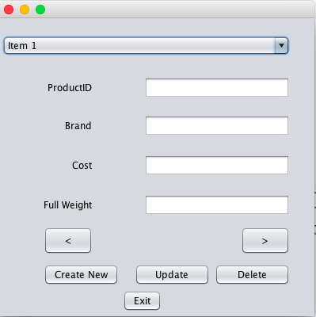
User selects product from drop down list and enters cost and full weight

(Flow Chart)
(table design ERD)

